Nutrition: The Basics
Many of the terms and concepts in this introductory guide may seem rudimentary to the average reader, however, bridging the gap between what is on paper and what your body is telling you in response can be an extremely complicated task. The key to applying nutritional concepts lies in understanding the fundamentals and how they interact.
Before considering any particular aspects in detail it is important to understand what universal characteristics should exist in any diet regardless of the objective that one hopes to achieve. This is not solely a question of overall health concern, as more often than not, any diet that fails to adhere several critical guidelines will not ultimately result in whatever purpose it was intended to achieve, whether it be to gain, lose, maintain weight, etc.
That being said the first key to any diet is to ensure that it includes the minimum amount of all of the macro nutrients. For dieting with the purpose of reducing body fat especially, it is key that all of the macro nutrients be consumed in their proper proportions, that means always incorporating carbohydrate and fat sources into the daily intake regimen. Whatever the body detects as being in scarce supply over its recent intake, it begins to hoard in a sense. Thus the first step to shedding excess body fat is supplying the body with the minimal amount it needs to function optimally. Furthermore, carbohydrates are a priority when it comes to fueling the brain, which takes precedence over the muscles, one function of carbohydrates (CHO) is known as the protein sparing action. When CHO are in too short a supply, the body begins to convert amino acids to glucose in order to supply the brain with adequate energy, meaning whatever protein was initially destined for muscle tissue is now reduced by whatever amount is necessary to appease the lack of available glucose. Caloric intakes with fat consisting of less than 15 to 20% of calories consumed have also been shown to reduce testosterone, which, in the long run, can greatly increase the rate at which the body accumulates fat.
It is also vital to ensure that, for diets aimed at weight loss, the overall caloric intake is not so low as to create a deficit in the overall energy balance of more than 500 to 1000 kcal. Eating too little or too infrequently will quickly slow down the body’s metabolism. A slower metabolism will greatly reduce the rate at which the body sheds its vital reserve energy stores.

A GOOD GENERAL GUIDE WHEN CONSIDERING NUTRIENT PROPORTIONS IS VARIABLE BUT THE ABOVE TABLE IS AN ADEQUATE RULE OF THUMB.
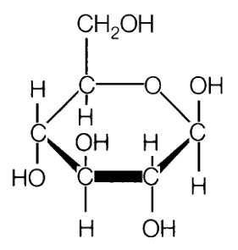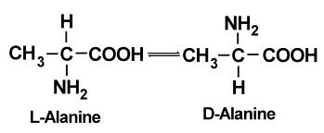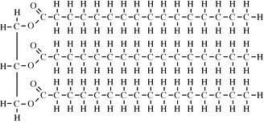
CARBOHYDRATE, PROTEIN, AND FAT RESPECTIVELY.
The major dietary constituents: the macronutrients. Carbohydrates, protein, fat – just about everything a person consumes on a daily basis is a composition of one or more of these basic macronutrients. The body obtains all of the energy it requires to sustain itself from these vital raw materials.
Carbohydrates are the body’s preferred source of energy. Although proteins and fats also possess the capability to be metabolized as energy, they perform a variety of other essential functions which tend to take precedence, and their conversion to a readily available energy source is comparatively inefficient. Although the body keeps what spare energy it has in the form of adipose tissue (body fat) for later use, these energy reserves are limited in capability and normally provide the means to support daily low intensity activities such as walking and others that do not require any significant use of muscular force. Thus, while fat primarily sustains very low intensity activities over a long duration, carbohydrates on the other hand, provide the means necessary to execute short, immediate bursts of high intensity movement, such as throwing a baseball (there is overlapping between the two energy pathways and to say that the body uses either/or for any given activity would be somewhat incorrect, but at the moment for simplicity’s sake we will consider them as if they were separate). These types of movements and their energy pathways fall under the general category of glycolysis, while those primarily sustained by adipose tissue stores are characterized as oxidative.
A carbohydrate is, in its most basic form, a molecule of simple sugar. Every structure thereafter, whether it be a piece of whole wheat bread or a stack of pancakes, is a combined variation of basic simple sugars. This is often somewhat contrary to what the manufacturers of health foods and diet plans lead many consumers to believe. What makes them different in terms of how they end up in the body is dependent on several factors. The underlying principle is very simple. Carbohydrates (CHO) are broken down and transported throughout the body via the circulatory system. When there is a need for replenishment along the way (a depleted muscle system for example) a portion of what CHO is available is then absorbed from the bloodstream and applied where necessary. This process occurs within a given window of time, afterwards any excess CHOs that are not currently in demand are then converted to and stored as adipose tissue. Therefore, the final destination for CHOs entering the body essentially depend on three factors: systemic demand, nutrient timing, and of course quantity available.
Systemic demand means to what degree the body is in need of CHOs. This begins with the default demands of the basil metabolic system. A person’s basil metabolic rate is the body’s minimum nutrient requirements to maintain homeostasis were it simply to exist in a state of rest, any activity beyond that adds additional requirements should a person continue to maintain a homeostatic energy balance. First and foremost in demand for glucose is the brain. Following the brain are the various tissues and their energy stores that may have become depleted. One of the main destinations for CHOs are the large reserve banks residing within the skeletal muscle tissue collectively known as glycogen. These stores are utilized regularly on any given day, the extent to which glycogen depletion occurs within any given muscle depends on the intensity, duration, and repetition of force output.

One very important function of CHOs, particularly when considering recovery, is the function known as protein sparing action.

Nutrient timing is another factor that can greatly influence the rate at which consumed CHOs are absorbed by the tissues or instead converted to body fat. First and foremost, CHO consumed closer to a depleting event such as a long run or an intense bout of resistance training, will ensure maximal absorption. However, this leads to the common belief that eating CHO at night or before sleeping will cause them to be converted to adipose tissue more so than if they were consumed earlier in the day. As long as there is a demand that has not been met such as depleted glycogen systems or otherwise, CHOs will be utilized first where they are most needed.
Quantity, is perhaps, the most simplistic of the factors governing the distribution pattern of CHOs within the body. At the end of the day the body has run up a list of activities with an end ‘balance’ or amount of CHO’s to the gram that are required balance out the body’s energy tab. What follows then is relatively clear cut and dry, consume a greater amount of CHO than needed, and you have an excess, which will potentially result in a weight gain of equal magnitude. Consume less, and you are at a deficit that will potentially result in weight loss. It is attempting to undertake the daunting task of being your own accountant, and making determinations as to what these numbers actually are where things get not so cut and dry.

